Startup Documentation

**The following will walk you through how to get started with development on this application**

**Environment**

Please have the following downloaded and installed before continuing:

* Java 8, Maven, STS (Or Eclipse but will require additional instructions), Angular CLI, npm, Git, SQL Developer, and RDS

**Generate a Local Database**

<https://raw.githubusercontent.com/revaturelabs/cms-content-service/dev/scripts/CMSForceSQL.sql>

**Setup Environment Variables**

**Environment Variables**

* **DB_URL** - Url connection to the database
* **DB_USER** - Username for the database
* **DB_PASS** - Password for the database
* **EUREKA_URL** - Url to the discovery service

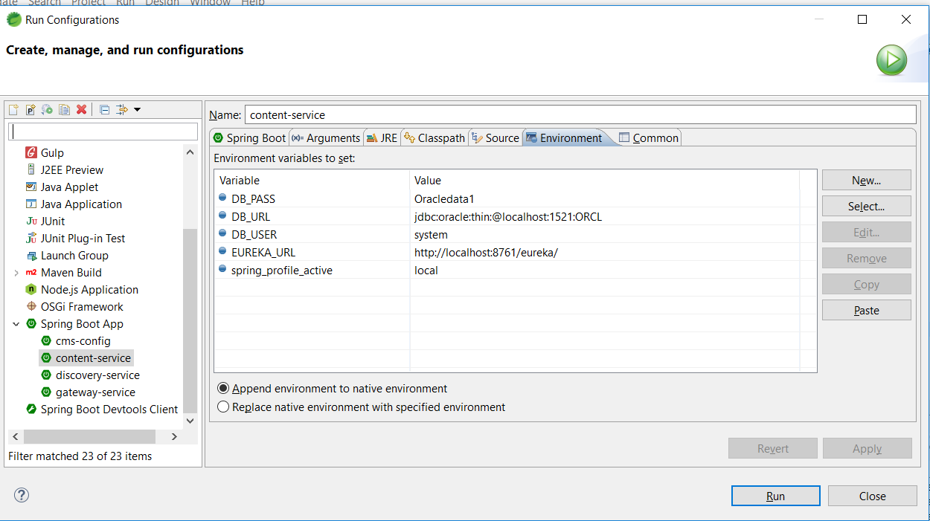

**Clone the project repositories to your local machine:**

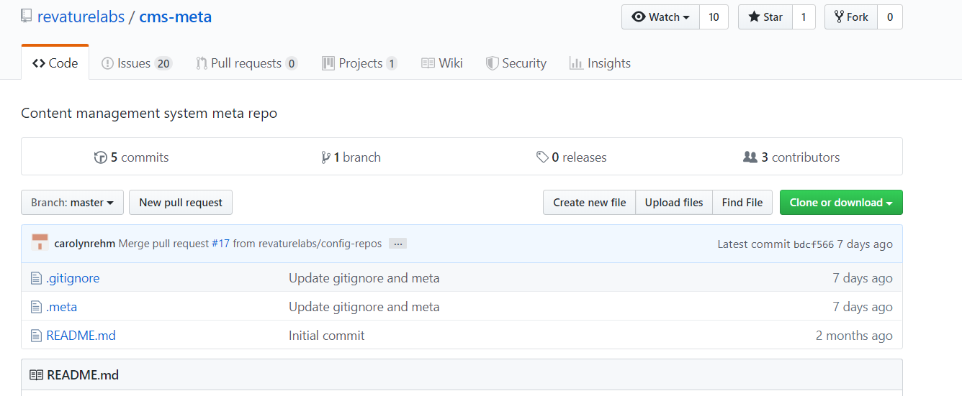

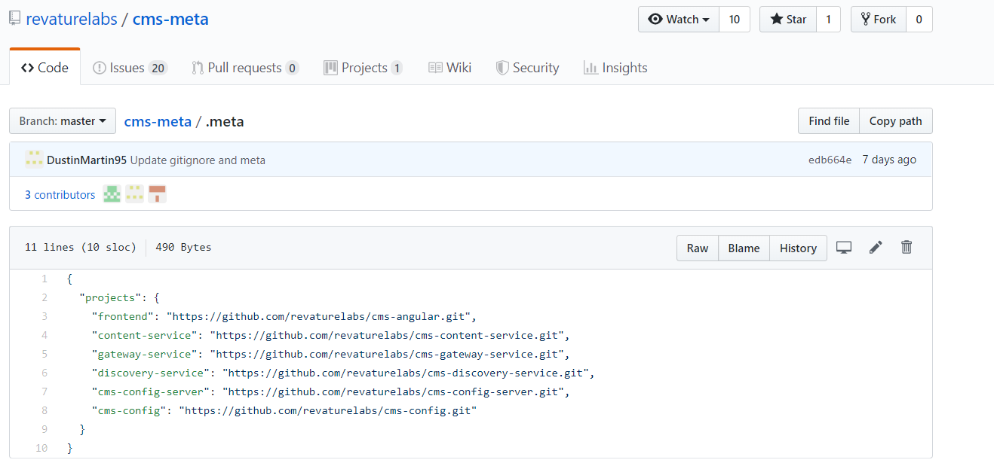

1. Create CMS folder.
2. C:\Ashujauhari2019\Revature\CMS Project3\cms>git init
3. C:\Ashujauhari2019\Revature\CMS Project3\cms>meta init
4. C:\Ashujauhari2019\Revature\CMS Project3\cms>meta git clone <https://github.com/revaturelabs/cms-meta.git>
5. 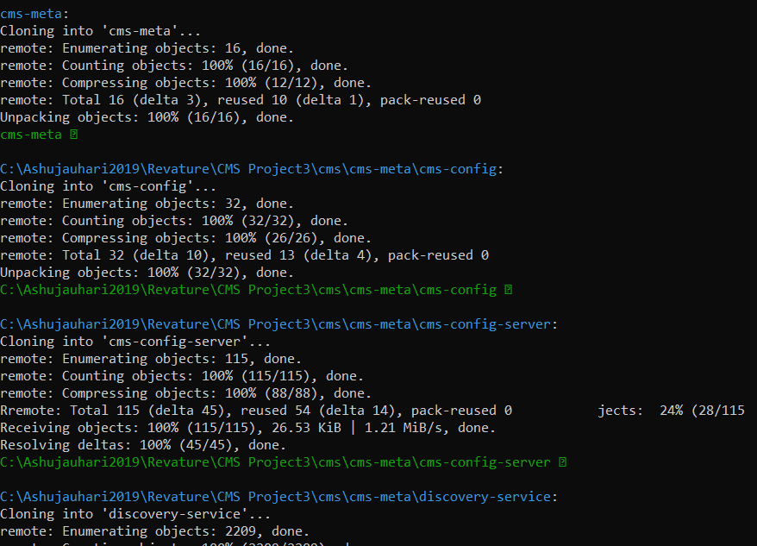
6. 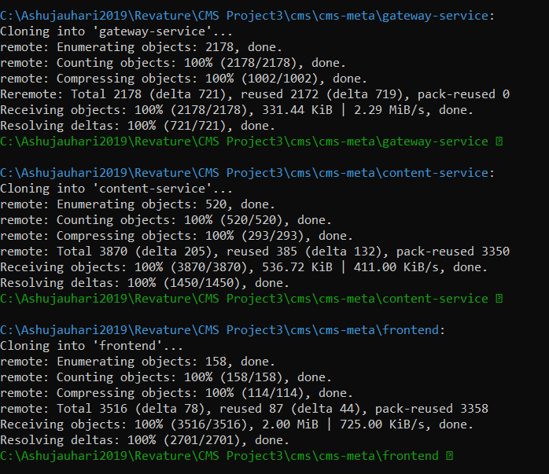
7. 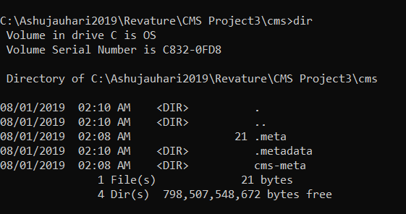

C:\Ashujauhari2019\Revature\CMS Project3\cms>cd cms-meta

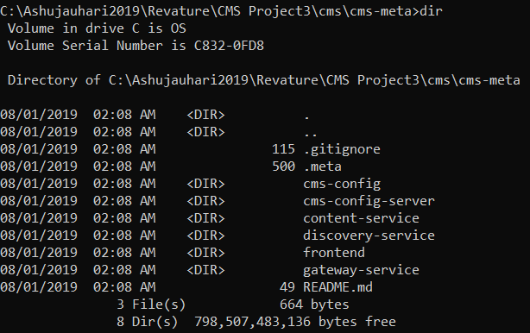

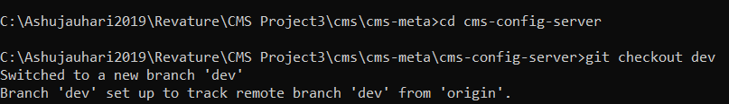

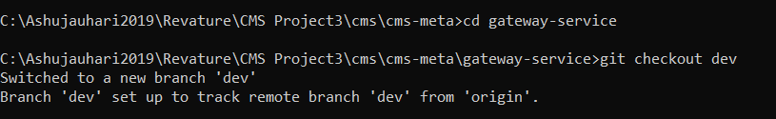

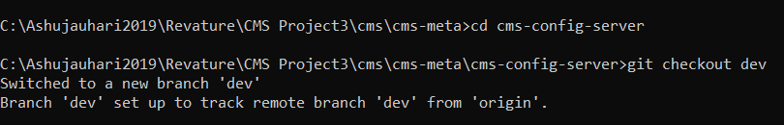

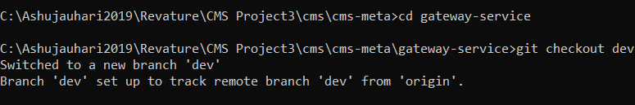

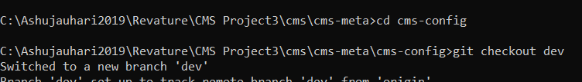

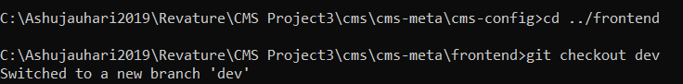



Verify

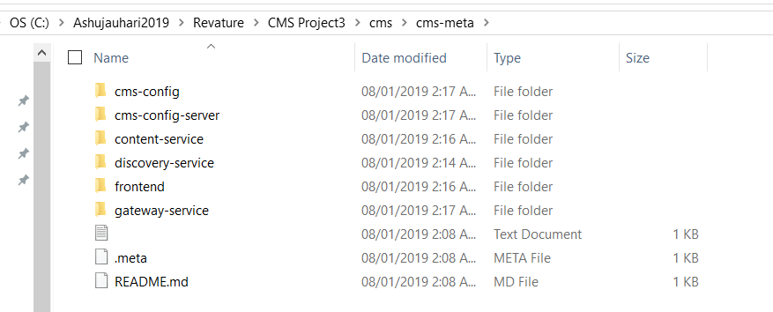

**Import the projects in new workspace of STS:**

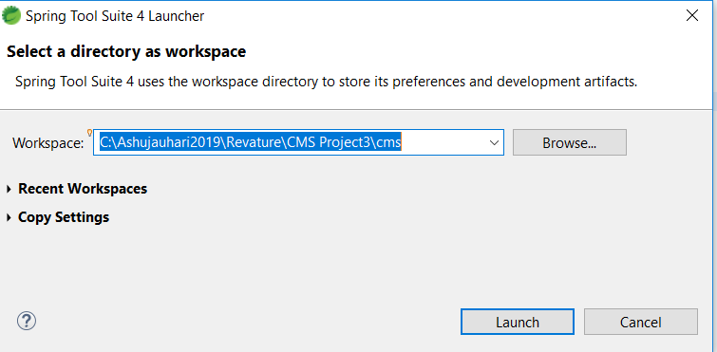

Import all Maven->existing project->

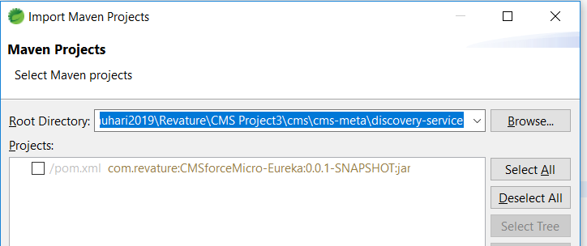

Repeat process the for all projects

1. Install meta (this allows you to run git commands across multiple repos):

npm i -g meta

1. Create a new directory for your meta project mkdir: [folder name]
2. Initialize a new git repository in your new dir:

cd [folder name] && git init

1. Initialize your new repository as a meta repo:

meta init

1. Clone the meta repository

meta git clone https://github.com/revaturelabs/cms-meta.git

cd cms-meta

1. Create branches based off dev for each repository.

Git checkout dev

**Set up work-space for STS**

1. In STS, got to file -> open projects from file system
2. Import all projects from cms-meta

**Eureka Default Zone**

* Discovery service

**Config Server**

* Centralized configuration

**Zuul Default Zone**

* You'll want to set your Zuul's defautZone to wherever you are hosting your Eureka(discovery) server.

**Application Server (CMSForce)**

* Content service

**Run the services:**

* If you set up windows, or OS environment variables, you will have to restart STS for it to have access to the OS environment variables if STS was running during setup.
* In STS, all of the services must be ran as a Spring Boot App

1. Run -> Run Configurations -> Profile: local -> Apply for all 4 services
2. Run Eureka Discovery Service
3. Run Config Server
4. Run Zuul Gateway Service
5. Run Content Service

**Run the Angular front end**

1. In a command line, navigate to the frontend directory of cms-meta
2. Install the dependencies:

npm install

1. Run the Angular development server

ng serve

* In your browser, navigate to <http://localhost:4200/>

Test

1 . Rc->Discoveryservice-> Run->Runconfiguration->select local in profile under discovery-service-+enter

1. Check eureka in browser

Setup for cms>

C:\Users\Ashu Jauhari\.m2\repository

------------Setup driver - ---

* 1. STS shows all folder
  2. Run Discovery service -> run- run-configuration -> environment –> set local profile
  3. Run config server-> set local profile -> run configuration-> set local
  4. Content – service
     1. Make sure oracle 12.1.9
     2. Run below in content-service

mvn install:install-file -Dfile=src/main/resources/ojdbc7.jar -DgroupId=com.oracle \  
    -DartifactId=ojdbc7 -Dversion=12.1.0 -Dpackaging=jar

* 1. Rc->run->runconfiguration->environment -> local-> FAIL TO DETERMINE SUITABLE DRIVER CLASS
  2. Open configdetail on browser
  3. Setup environment variable -> STS-> run configuration -> environment variable-> DB_URL->DB_Password-> DB_USER
  4. As there were changes in cms-config-server and gateway service
  5. Go bootstrap.yml-> in dev -> eureka.client.service-url:defaultzone: <http://localhost:8761/eureka/>

// -DB Script

/*Setup Script*/

drop table content_module;

drop table module;

drop table content;

create table content(

c_id number (10) primary key,

title varchar2 (200) not null,

format varchar2 (200) not null,

description varchar2 (200) not null,

url varchar2 (200) not null,

created number (20),

last_modified number (20)

);

create table module(

m_id number (10) primary key,

subject varchar2 (200) unique,

created number (20)

);

create table link(

cm_id number (10) primary key,

fk_c number (10) ,

affiliation varchar2 (200),

fk_m number (10),

foreign key (fk_c) references content(c_id) on delete cascade,

foreign key (fk_m) references module(m_id)on delete cascade

);

create sequence HIBERNATE_SEQUENCE;

select * from module;

Add a new repo(empty) in git hub

How to update it.

* + 1. Go to auth-service repo in Github.
    2. Create new branch – click left corner in github repo.
    3. Go to cmd in cms-meta
    4. Clone the repo
    5. Git checkout new branch
    6. Git pull
    7. Add code to folder.
    8. Git add
    9. Git commit –m “added code”
    10. Git push
    11. Check in github for reflection.